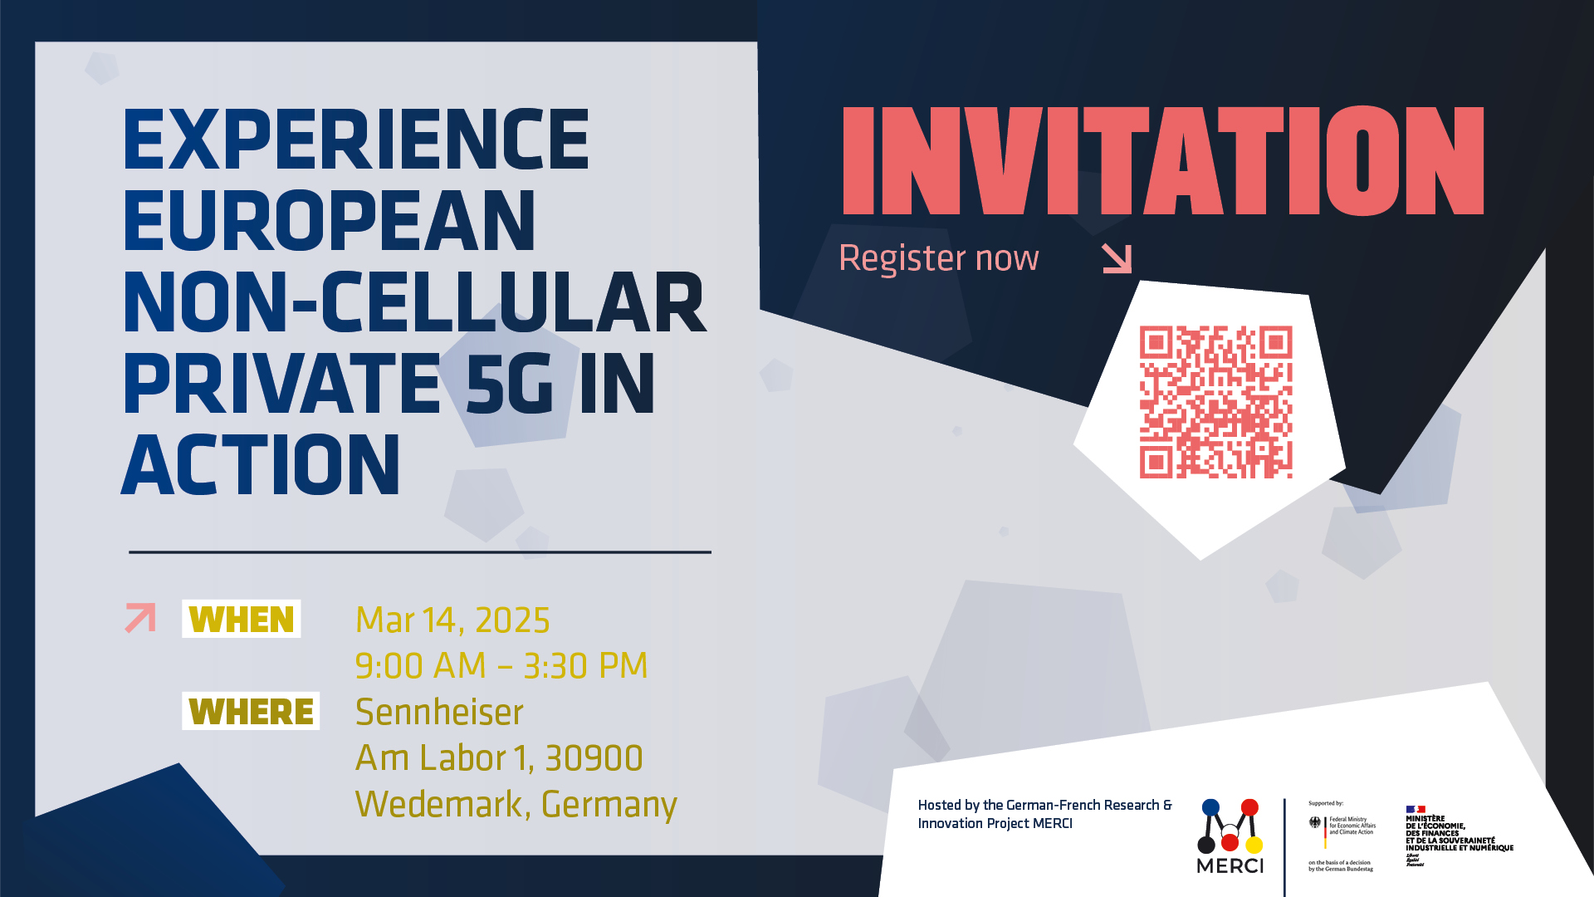

Experience Europe’s innovative non-cellular 5G wireless technology
Final workshop of the MERCI consortium showcases DECT NR+ demonstrators at Sennheiser head office in Wedemark

Wedemark, 4 March 2025 – The Franco-German innovation project “MERCI” invites all interested persons, stakeholders, and media to its concluding workshop, to be held at the Sennheiser head office in Wedemark, Germany on 14 March, 9 a.m. to 3.30 p.m. The MERCI consortium will present the results of a 30-month research collaboration between the media & events sector, industry partners, and universities. The public workshop maps the state of the art of private 5G networks for the industry, and showcases various demonstrators that reveal the huge potential of DECT NR+ technology.

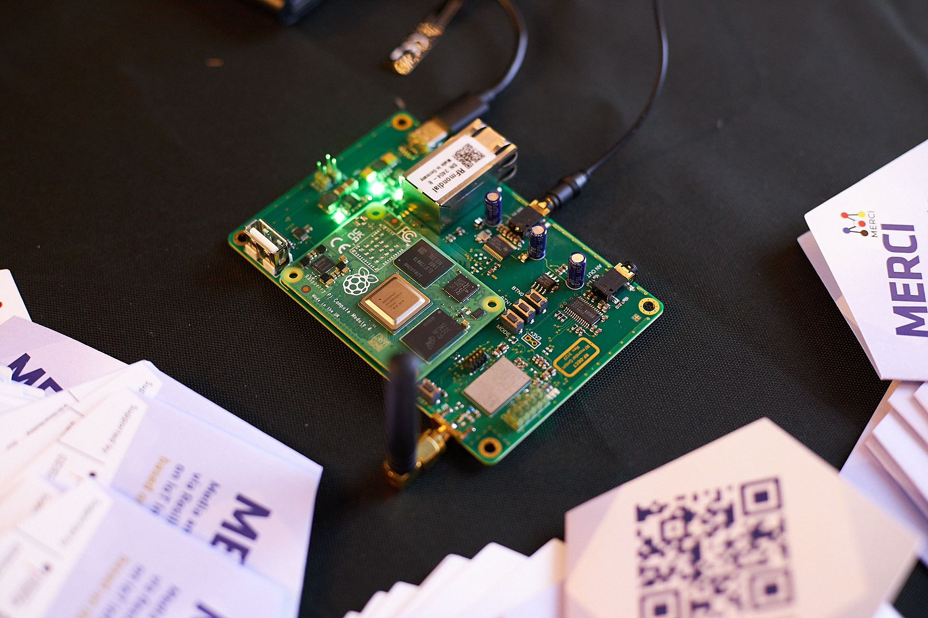 | The DECT NR+ evaluation circuit board  (The picture was taken at the recent 5G Conference in Brussels, photo credit: Julia Jung)

“We are delighted to be hosting the final MERCI workshop at the Sennheiser head office in Wedemark,” says Dr Andreas Wilzeck, Sennheiser’s Head of Spectrum Policies and Standards, and Consortium Lead of MERCI. “On behalf of MERCI, I’d like to extend an invitation to all interested individuals to experience this future wireless technology today.”

The demonstrators on hand include the DECT NR+ evaluation board, based on the chipset from associated partner Nordic Semiconductor; an audio interview transmission over DECT NR+; MPEG-H object audio via DECT NR+, including processing and distribution; an SDR (software defined radio) implementation of DECT NR+; and an industrial control protocol for Automated Guided Vehicles (AGV) over DECT NR+.

The day will close with a much anticipated live gig by US band Sonic Crusaders. The Sonic Crusaders are a band of veteran performing artists based in the United States, who are on a noble quest to spread love, peace, hope and joy through the magic of music. Their live shows are full of energy and jam packed with fun, performing classic rock hits and originals, including their latest release Hindsight.

The Sonic Crusaders will come to Wedemark and play live at the MERCI final workshop on 14 March

To learn more about DECT NR+ and experience the technology in action, register here to reserve your free ticket: https://www.merci-5g.eu/merci-final-workshop/

The MERCI Project
MERCI stands for Media and Event production via Resilient Communication on IoT Infrastructure. Jointly funded by the German Federal Ministry for Economic Affairs and Climate Action, the French Ministère de l’Economie et des Finances et de la Relance (MEFR) and bpi France, MERCI aims to develop innovative solutions for private 5G networks based on or complemented by DECT-2020 NR. This is done through cooperation between the media & events sector which produces and distributes content and the industrial IoT sector. Both have similar needs and interests, and may co-exist or even be used together.
MERCI consortium partners are Ateme, Leibniz Universität Hannover, Ostfalia, RF Mondial, R3 Solutions, Sennheiser, Vitec and Wirepas. Associated partners include Bayerischer Rundfunk, Bundesnetzagentur, dect forum, Götting and Nordic Semiconductor.
https://franco-german-5g-ecosystem.eu/merci/
https://www.merci-5g.eu/

DECT NR+
DECT-2020 NR is internationally recognised by the ITU-R as IMT-2020 (5G) standard for URLLC and mMTC, while also enabling reliable broadband communications. As an open ETSI standard living the 5G/6G vision, DECT-2020 NR can be one of the key innovation drivers for increased economic and technological sovereignty in Europe. 5G private networks will be possible for everyone, even in dense deployments, without any business difficulties or economic burdens. Therefore, they can contribute to productivity gains through industry-driven, flexible implementation of value-added and sustainable solutions. The MERCI project aims to contribute significantly to this vision.

(Ends)

For your social media channels
Find a selection of banners and tiles here.

Images
The high-resolution images accompanying this media release can be downloaded here.

The Agenda for March 14
08:00 – 09:00: Welcome – Registration and Morning Coffee
09:00 – 09:30: The MERCI Universe – Welcome and Introduction
09:30 – 10:00: Decoding MERCI – Comprehensive Project Overview
10:00 – 10:30: Vision for the Future – Keynote by the Chair of TC DECT
10:30 – 10:45: Taste of Innovation – Brief Introduction to the MERCI Demos
10:45 – 13:00: Experience MERCI Up Close – Interactive Demo Sessions, Networking with Lunch Buffet from 12:00
13:00 – 13:15: Expanding Horizons – MERCI’s Future Perspectives
13:15 – 15:30: Live Performance by the Sonic Crusaders

About the Sennheiser brand
We live and breathe audio. We are driven by the passion to create audio solutions that make a difference. Building the future of audio and bringing remarkable sound experiences to our customers – this is what the Sennheiser brand has represented for more than 75 years. While professional audio solutions such as microphones, meeting solutions, streaming technologies and monitoring systems are part of the business of Sennheiser electronic SE & Co. KG, the business with consumer devices such as headphones, soundbars and speech-enhanced hearables is operated by Sonova Holding AG under the license of Sennheiser.

www.sennheiser.com
www.sennheiser-hearing.com

Global Press Contacts
Jeff Horan Stephanie Schmidt
jeff.horan@sennheiser.com stephanie.schmidt@sennheiser.com
+1 (860) 598 7539 +49 (5130) 600 – 1275

